Rated Voltage up to 0.6/1kV PVC Insulated Power Cable
The product is used for electrical power transmission and distribution systems, operating at A.C. rated voltage (Uo/U) up to 0.6/1kV.
1. Manufacturing Standards:
The standards are GB/T12706-2002, IEC60502.
2. Application requirements:
Max. permissive operating temperature of conductor in long-term is 70℃.

- The conductor short-circuit temperature shall not exceed 160℃ (duration no more than 5s).
- The ambient temperature shall not be lower than 0℃ during installation. The minimum bending radius shall be as follows:
For single core cable: 20（D＋d）±5％mm
For multi-core cable: 15（D＋d）±5％mm
where:
D is the actual outer diameter of the cable mm;
d is the actual outer diameter of the conductor) mm.
- Type and Specification:

a. Refer to table 1 about the type:
Table 1
Type |  | Name
VV | VLV | PVC insulated PVC sheathed power cable
VY | VLY | PVC insulated PE sheathed power cable
VV22 | VLV22 | PVC insulated PVC sheathed steel-tape armored power cable
VV23 | VLV23 | PVC insulated PE sheathed steel-tape armored power cable
VV32 | VLV32 | PVC insulated PVC sheathed thin steel-wire armored power cable
VV33 | VLV33 | PVC insulated PE sheathed thin steel-wire armored power cable
VV42 | VLV42 | PVC insulated PVC sheathed thick steel-wire armored power cable
VV43 | VLV43 | PVC insulated PE sheathed thick steel-wire armored power cable
Note:
Our company can also produce flame-retardant, fire-resistant, anti-termite, low smoke and non-halogen cables respectively according to the requirements of customers.
for flame-retardant cables, the writing “ZRA-”, “ZRB-”, “ZRC-” is added respectively;
for fire-resistant cables, the writing “NH-” is added;
for low smoke and non-halogen cables, the writing “DWZR-” is added;
for low smoke and low-halogen cables, the writing “DDZR-” is added.

b. Refer to table 2 about the specification:
Table 2
Rated voltage kV | Type | No. of Cores | Nominal Cross-sectional Area mm²
0.6/1 | VV VLV  VY VLY  VV22 VLV22  VV23 VLV23  VV32 VLV32  VV33 VLV33  VV42 VLV42  VV43 VLV43 | 1 | 1.5―800
0.6/1 |  | 2 | 1.5―400
0.6/1 |  | 3 | 1.5―400
0.6/1 |  | 4 | 4―400
0.6/1 |  | 3＋1 | 4―400
0.6/1 |  | 4＋1 | 6―300
0.6/1 |  | 3＋2 | 6―300
0.6/1 |  | 5 | 1.5―300
Note:
Armor of single core cable used for A.C system should be non-magnetic material except for special construction.
- Referential data:
outer diameter, weight (see table 3-table 12) and construction (see fig.1-fig. 13)

Nominal thickness of insulation:
Nominal Cross-sectional Area of Conductormm² | 1.5、2.5 | 4～6 | 25、35 | 50、70 | 90、120 | 150 | 185 | 240 | 300 | 400 | 500～800
Nominal Thickness of Insulation  mm | 0.7 | 1.0 | 1.2 | 1.4 | 1.6 | 1.8 | 2.0 | 2.2 | 2.4 | 2.6 | 2.8

Single core non-armored cable Table3
No. of Core  ×  Cross-sectional Area mm² | Non-armored Cable
No. of Core  ×  Cross-sectional Area mm² | Approx. Outer Diameter mm | Approx. Weight kg/km
No. of Core  ×  Cross-sectional Area mm² | Approx. Outer Diameter mm | VV | VLV
1×1.5 | 6.1 | 50 | 41
1×2.5 | 6.5 | 63 | 47
1×4 | 7.4 | 87 | 62
1×6 | 7.9 | 110 | 73
1×10 | 9.2 | 162 | 99
1×16 | 10.2 | 226 | 126
1×25 | 12.0 | 331 | 175
1×35 | 13.1 | 431 | 214
1×50 | 14.9 | 577 | 279
1×70 | 16.7 | 779 | 356
1×95 | 19.1 | 1064 | 476
1×120 | 20.6 | 1293 | 560
1×150 | 23.0 | 1613 | 695
1×185 | 25.4 | 2001 | 856
1×240 | 28.7 | 2614 | 1100
1×300 | 31.7 | 3233 | 1346

Two Cores Cable Table 4
No. of Core  ×  Cross-sectional Area  mm² | Non-armored Cable |  |  | Steel-tape Armored Cable
No. of Core  ×  Cross-sectional Area  mm² | Approx. Outer Diameter mm | Approx. Weight kg/km |  | Approx. Outer Diameter mm | Approx. Weight  kg/km
No. of Core  ×  Cross-sectional Area  mm² | Approx. Outer Diameter mm | VV | VLV | Approx. Outer Diameter mm | VV | VLV
2×1.5 | 9.8×6.7 | 94 | 75 | － | － | －
2×2.5 | 10.6×7.1 | 119 | 89 | － | － | －
2×4 | 14.0 | 213 | 163 | 16.8 | 383 | 334
2×6 | 15.1 | 263 | 188 | 17.9 | 446 | 370
2×10 | 17.7 | 372 | 244 | 20.5 | 586 | 458
2×16 | 19.8 | 513 | 310 | 22.6 | 752 | 550
2×25 | 22.1 | 736 | 426 | 25.5 | 987 | 677
2×35 | 24.1 | 949 | 515 | 27.5 | 1267 | 833
2×50 | 24.1 | 1276 | 656 | 27.5 | 1824 | 1204
2×70 | 25.3 | 1712 | 844 | 29.7 | 2324 | 1456
2×95 | 28.1 | 2168 | 990 | 33.2 | 2876 | 1698
2×120 | 31.9 | 2570 | 1082 | 37.3 | 3344 | 1856
2×150 | 34.7 | 3220 | 1360 | 39.8 | 4114 | 2254
2×185 | 42.1 | 3969 | 1675 | 47.6 | 4964 | 2670
Note: The conductor of black writing is round and the conductor of red writing is sector shape.

Three Cores Cable Table 5
No. of Core  ×  Cross-sectional Area  mm² | Non-armored Cable |  |  | Steel-tape Armored Cable
No. of Core  ×  Cross-sectional Area  mm² | Approx. Outer Diameter mm | Approx. Weight kg/km |  | Approx. Outer Diameter mm | Approx. Weight  kg/km
No. of Core  ×  Cross-sectional Area  mm² | Approx. Outer Diameter mm | VV | VLV | Approx. Outer Diameter mm | VV | VLV
3×1.5 | 11.9 | 148 | 120 | － | － | －
3×2.5 | 12.8 | 187 | 140 | － | － | －
3×4 | 14.7 | 265 | 191 | 17.5 | 443 | 369
3×6 | 15.8 | 336 | 224 | 18.6 | 527 | 415
3×10 | 18.6 | 501 | 309 | 21.4 | 726 | 534
3×16 | 20.9 | 677 | 319 | 23.7 | 946 | 643
3×25 | 24.0 | 1017 | 547 | 27.4 | 1315 | 845
3×35 | 22.2 | 1315 | 617 | 25.4 | 1669 | 972
3×50 | 25.9 | 1800 | 818 | 30.3 | 2448 | 1467
3×70 | 28.7 | 2447 | 1066 | 33.1 | 3156 | 1780
3×95 | 33.1 | 3230 | 1403 | 37.3 | 4029 | 2202
3×120 | 35.8 | 3890 | 1654 | 40.0 | 4751 | 2515
3×150 | 39.8 | 4550 | 2051 | 44.6 | 5871 | 3067
3×185 | 44.0 | 5908 | 2498 | 48.6 | 7005 | 3596
3×240 | 48.9 | 7740 | 3214 | 54.0 | 9004 | 4478
Note: The conductor of black writing is round and the conductor of red writing is sector shape.

Three Cores Cable Table 6
No. of Core  ×  Cross-sectional Area  mm² | Thin Steel-wire Armored Cable
No. of Core  ×  Cross-sectional Area  mm² | Approx. Outer Diameter  mm | Approx. Weight kg/km
No. of Core  ×  Cross-sectional Area  mm² | Approx. Outer Diameter  mm | VV32 | VLV32
3×35 | 27.6 | 2131 | 1433
3×50 | 32.3 | 2961 | 1979
3×70 | 35.1 | 3721 | 2344
3×95 | 39.5 | 4686 | 2859
3×120 | 43.1 | 5834 | 3598
3×150 | 47.8 | 7075 | 4271
3×185 | 51.8 | 8336 | 4926
3×240 | 57.1 | 10482 | 5956

3＋1Core Cable Table 7
No. of Core  ×  Cross-sectional Area  mm² | Non-armored Cable |  |  | Steel-tape Armored Cable
No. of Core  ×  Cross-sectional Area  mm² | Approx. Outer Diameter  mm | Approx. Weight kg/km |  | Approx. Outer Diameter mm | Approx. Weight kg/km
No. of Core  ×  Cross-sectional Area  mm² | Approx. Outer Diameter  mm | VV | VLV | Approx. Outer Diameter mm | VV22 | VLV22
3×4＋1×2.5 | 15.3 | 313 | 223 | 18.2 | 499 | 409
3×6＋1×4 | 16.8 | 405 | 268 | 19.6 | 609 | 472
3×10＋1×6 | 19.5 | 594 | 365 | 22.3 | 831 | 610
3×16＋1×10 | 22.2 | 834 | 468 | 25.0 | 1103 | 736
3×25＋1×16 | 26.0 | 1219 | 649 | 28.8 | 1534 | 964
3×35＋1×16 | 24.4 | 1625 | 727 | 27.6 | 1914 | 1116
3×50＋1×25 | 28.2 | 2122 | 980 | 32.4 | 2809 | 1668
3×70＋1×35 | 31.4 | 2869 | 1276 | 35.6 | 3631 | 2008
3×95＋1×50 | 36.4 | 3801 | 1675 | 40.6 | 4676 | 2550
3×120＋1×70 | 38.9 | 4656 | 1999 | 43.9 | 5630 | 2974
3×150＋1×70 | 43.0 | 5632 | 2408 | 47.6 | 6674 | 3450
3×185＋1×95 | 47.4 | 6960 | 2961 | 52.0 | 8140 | 4140
3×240＋1×120 | 52.6 | 9018 | 3758 | 57.7 | 10376 | 5115
Note: The conductor of black writing is round and the conductor of red writing is sector shape.

3＋1 Core Cable Table 8
No. of Core  ×  Cross-sectional Area  mm² | Thin Steel-wire Armored Cable
No. of Core  ×  Cross-sectional Area  mm² | Approx. Outer Diameter mm | Approx. Weight kg/km
No. of Core  ×  Cross-sectional Area  mm² | Approx. Outer Diameter mm | VV32 | VLV32
3×35＋1×16 | 29.8 | 2415 | 1618
3×50＋1×25 | 34.6 | 3398 | 2256
3×70＋1×35 | 37.8 | 4264 | 2671
3×95＋1×50 | 42.8 | 5403 | 3276
3×120＋1×70 | 46.7 | 6931 | 4275
3×150＋1×70 | 50.8 | 7980 | 4756
3×185＋1×95 | 55.2 | 9569 | 5570
3×240＋1×120 | 60.9 | 11947 | 6686

4 Cores Cable Table 9
No. of Core  ×  Cross-sectional Area  mm² | Non-armored Cable |  |  | Steel-tape Armored Cable
No. of Core  ×  Cross-sectional Area  mm² | Approx. Outer Diameter mm | Approx. Weight kg/km |  | Approx. Outer Diameter mm | Approx. Weight kg/km
No. of Core  ×  Cross-sectional Area  mm² | Approx. Outer Diameter mm | VV | VLV | Approx. Outer Diameter mm | VV22 | VLV22
4×4 | 15.9 | 328 | 229 | 18.7 | 521 | 422
4×6 | 17.1 | 421 | 271 | 19.9 | 629 | 479
4×10 | 20.2 | 537 | 381 | 23.0 | 882 | 628
4×16 | 22.8 | 890 | 486 | 25.6 | 1166 | 792
4×25 | 27.0 | 1314 | 890 | 29.8 | 1641 | 1014
4×35 | 24.1 | 1714 | 784 | 27.5 | 2110 | 1180
4×50 | 27.9 | 2361 | 1053 | 32.3 | 3055 | 1746
4×70 | 31.3 | 3226 | 1390 | 35.5 | 3982 | 2146
4×95 | 36.0 | 4252 | 1816 | 40.4 | 5135 | 2699
4×120 | 38.5 | 5119 | 2138 | 43.3 | 6103 | 3121
4×150 | 42.8 | 6409 | 2671 | 47.4 | 7483 | 3743
4×185 | 47.2 | 7796 | 3250 | 52.2 | 9015 | 4469
4×240 | 52.4 | 10217 | 4184 | 57.4 | 11566 | 5531
Note: The conductor of black writing is round and the conductor of red writing is sector shape.

3+2 Cores Cable Table 10
No. of Core  ×  Cross-sectional Area  mm² | Non-armored Cable |  |  | Steel-tape Armored Cable
No. of Core  ×  Cross-sectional Area  mm² | Approx. Outer Diameter mm | Approx. Weight kg/km |  | Approx. Outer Diameter  mm | Approx. Weight kg/km
No. of Core  ×  Cross-sectional Area  mm² | Approx. Outer Diameter mm | VV | VLV | Approx. Outer Diameter  mm | VV22 | VLV22
3×25＋2×16 | 27 | 1420 | 683 | 31 | 2212 | 1373
3×35＋2×16 | 29 | 1733 | 804 | 32 | 2601 | 1487
3×50＋2×25 | 33 | 2480 | 1129 | 38 | 3474 | 2100
3×70＋2×35 | 38 | 3381 | 1457 | 42 | 4455 | 2536
3×95＋2×50 | 43 | 4602 | 1956 | 48 | 5865 | 2986
3×120＋2×70 | 48 | 5770 | 2396 | 53 | 7190 | 3816
3×150＋2×70 | 52 | 6952 | 2881 | 57 | 8551 | 4479
3×185＋2×95 | 58 | 8780 | 3671 | 63 | 10696 | 5588
3×240＋2×120 | 64 | 10749 | 4445 | 69 | 13676 | 7373
3×300＋2×150 | 71 | 13849 | 5632 | 76 | 16272 | 8607

4+1 Core Cable Table 11
No. of Core  ×  Cross-sectional Area  mm² | Non-armored Cable |  |  | Steel-tape Armored Cable
No. of Core  ×  Cross-sectional Area  mm² | Approx. Outer  Diameter  mm | Approx. Weight kg/km |  | Approx. Outer Diameter  mm | Approx. Weight kg/km
No. of Core  ×  Cross-sectional Area  mm² | Approx. Outer  Diameter  mm | VV | VLV | Approx. Outer Diameter  mm | VV22 | VLV22
4×25＋16 | 28 | 1535 | 730 | 32 | 2330 | 1525
4×35＋16 | 30 | 1948 | 877 | 35 | 2745 | 1674
4×50＋25 | 35 | 2723 | 1216 | 40 | 3700 | 2193
4×70＋35 | 40 | 3740 | 1580 | 44 | 4834 | 2675
4×95＋50 | 45 | 5096 | 2124 | 50 | 6059 | 3087
4×120＋70 | 51 | 6266 | 2571 | 55 | 7755 | 4060
4×150＋70 | 55 | 7813 | 3190 | 60 | 9480 | 4858
4×185＋95 | 61 | 9716 | 4004 | 66 | 12449 | 6737
4×240＋120 | 68 | 11943 | 4877 | 73 | 15006 | 7940
4×300＋150 | 75 | 15401 | 6171 | 81 | 18833 | 9603

5 Cores Cable Table 12
No. of Core  ×  Cross-sectional Area  mm² | Non-armored Cable |  |  | Steel-tape Armored Cable
No. of Core  ×  Cross-sectional Area  mm² | Approx. Outer  Diameter  mm | Approx. Weight kg/km |  | Approx. Outer Diameter  mm | Approx. Weight kg/km
No. of Core  ×  Cross-sectional Area  mm² | Approx. Outer  Diameter  mm | VV | VLV | Approx. Outer Diameter  mm | VV22 | VLV22
5×16 | 25 | 1020 | 520 | 29 | 1530 | 1030
5×25 | 28 | 1740 | 815 | 32 | 2618 | 1691
5×35 | 31 | 2287 | 1015 | 35 | 3281 | 2010
5×50 | 36 | 3120 | 1375 | 41 | 4310 | 2560
5×70 | 40 | 4301 | 1806 | 45 | 5648 | 3060
5×95 | 47 | 5880 | 2427 | 52 | 7551 | 4090
5×120 | 51 | 7105 | 2890 | 57 | 9183 | 4718
5×150 | 57 | 9115 | 3681 | 63 | 11428 | 5744
5×185 | 62 | 11197 | 4566 | 68 | 13706 | 6875
5×240 | 70 | 13805 | 5586 | 76 | 16625 | 8208
5×300 | 78 | 17850 | 7095 | 84 | 20986 | 10231

- Referential Carrying Capacity of Cable (see table 13-table 14):

a. Refer to table 13 about referential carrying capacity of single core PVC insulated power cable
Table 13
Type | VV、VLV、VY、VLY
Voltage | 0.6/1KV
Arrangement | ○  ○ ○ Trefoil (in contact) |  |  |  |  | ○○○ Parallel (the distance between two adjacent cables is the outer diameter of cable)
Installation Condition | In Air |  |  | Underground |  | In Air |  |  | Underground
Cross-sectional Area mm² | Cu | Al |  | Cu | Al | Cu | Al |  | Cu | Al
1.5  2.5  4  6  10  16  25  35  50  70  95  120  150  185  240  300  400 | 19  25  33  41  57  76  98  115  145  180  225  260  300  345  410  475  555 | －  19  26  34  44  59  76  90  110  140  175  200  230  270  320  370  440 |  | 27  36  47  58  78  100  130  155  185  255  270  310  350  395  455  515  585 | －  27  35  46  58  76  98  115  140  170  205  235  265  300  350  395  455 | 24  31  41  52  72  95  120  150  180  230  280  325  375  430  510  585  690 | －  24  32  42  55  73  96  115  140  175  215  250  290  335  395  455  540 |  | 29  38  49  61  83  105  135  160  195  240  285  325  365  415  480  545  625 | －  30  39  50  64  83  105  125  150  185  220  250  285  320  375  425  490
Operating Temperature ℃ |  | 70
Ambient Temperature ℃ |  | 40 | 25 |  |  | 40 |  | 25
(1) ρ_{w:} soil thermal resistivity without water loss 1.0 k..m/w.
(2) The referential carrying capacity of 2 cores and above PVC insulated and sheathed power cable is stipulated in table 14.
(3) Correction coefficient of current rating under different ambient temperature is stipulated in table 15. (4) Correction coefficient of current rating under different ground thermal resistivity is stipulated in table 16.

Table 14
Cross-sectional Area mm² | In Air |  |  |  |  | Underground
Cross-sectional Area mm² | Two Cores |  | Three Cores and above |  |  | Two Cores |  | Three Cores and above
Cross-sectional Area mm² | VV | VLV | VV | VLV |  | VV | VLV | VV | VLV
1.5  2.5  4  6  10  16  25  35  50  70  95  120  150  185  240  300 | 17  23  31  38  53  71  90  110  135  165  210  245  280  320  －  － | －  18  24  32  42  55  70  86  105  130  165  190  215  250  －  － | 15  19  26  32  46  60  77  95  115  145  185  210  245  280  335  375 | －  15  20  26  35  47  60  74  90  115  140  165  190  215  260  295 |  | 27  35  47  58  80  105  133  164  201  244  275  310  350  395  －  － | －  28  36  45  62  82  104  127  159  186  210  245  275  310  －  － | 22  30  39  49  68  89  107  131  159  195  231  262  300  337  390  435 | －  23  31  38  52  69  83  101  123  150  178  201  231  262  301  340
Operating Temperature ℃ | 70
Ambient Temperature ℃ | 40 |  |  |  | 25
Note: ρ_{w:} soil thermal resistivity without water loss. 1.0k..m/w.

Table 15
Operating Temperature of Conductor℃ | Ambience | Different Ambient Temperature ℃
Operating Temperature of Conductor℃ | Ambience | 10 | 15 | 20 | 25 | 30 | 35 | 40 | 45 | 50
70 | In Ground | 1.15 | 1.11 | 1.05 | 1.00 | 0.94 | 0.88 | － | － | －
70 | In Air | 1.41 | 1.35 | 1.29 | 1.22 | 1.15 | 1.08 | 1.00 | 0.91 | 0.81

Table 16
Voltage | Cross-sectional Area | Ground Thermal Resistivity
kV | mm² | 0.8 | 1.0 | 1.2 | 1.5 | 2.0
1 | 35 and Up to  50－120  150－300  400 and above | 1.06  1.08  1.08  1.09 | 1.00  1.00  1.00  1.00 | 0.95  0.94  0.93  0.93 | 0.89  0.87  0.86  0.85 | 0.81  0.77  0.76  0.76
- Main Technical Data:
a. The finished cable should withstand the testing voltage (50Hz A.C.) at ambient temperature. The testing voltage is stipulated in Table 17. Single core non-armored cable must be tested after immersion in water for 1 hour.
Table 17
Rated Voltage kV | Testing Voltage kV | Time min
0.6/1.0 | 3.5 | 5
Testing voltage shall be 2.4 times of the A.C. voltage when D.C. voltage is used in the test.
b. The cable should withstand D.C testing after installation. We suggest that the testing voltage should be 4U₀ (U₀ refer to voltage against ground of conductor). Time is 5 minutes.
c. Mechanical performance of the cable insulation and sheath is stipulated in table 18.
Special test of cable insulation and sheath is stipulated in table 19 and table20 respectively.
- Delivery Length:
The delivery length of the cable shall not be less than 100 meters.
With the amount of short strands being 10% of the total length, the length for each short strand is not less than 20 meters.
The delivery length can be decided through negotiation by both parties.
- Writing of type and size to order:
Please indicate the type, specification, voltage, standards and quantity.
For example, 1kV, 3 cores, 240mm² aluminum conductor PVC insulated, PVC sheathed, steel-tape armored power cable, 4km.
Indicate as: VLV22-0.6/1.0 kV 3×240 mm² 4km GB/T 12706-2002(or IEC60502)

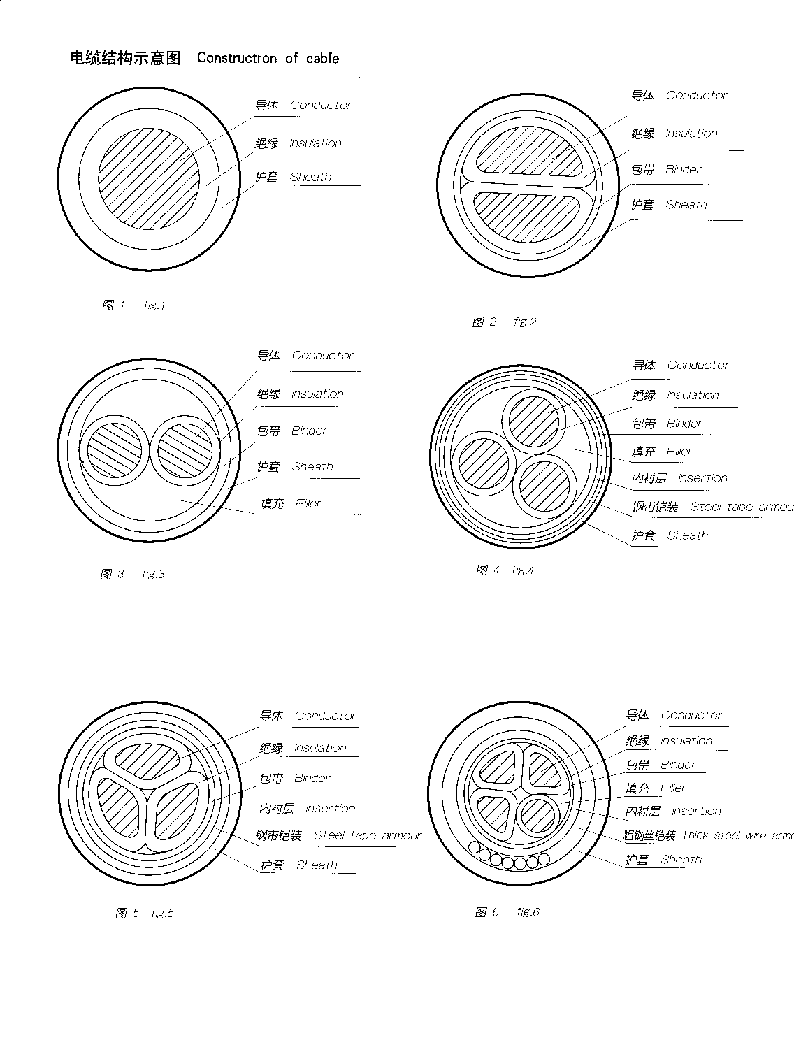

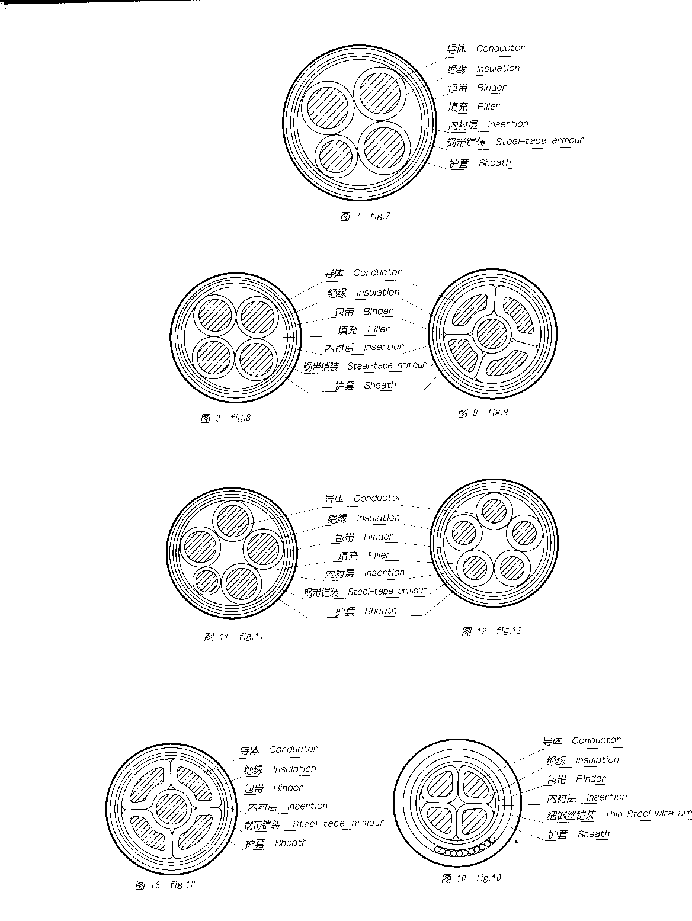

Mechanical Performance of Insulation and Sheath Table 18
Item | Material
Item | PVC Insulation | PVC Sheath | PE Sheath
Mechanical Performance before aging
Min. Tensile Strength N/mm2 | 12.5 | 12.5 | 10.0
Min. Elongation at Break ％ | 150 | 150 | 300
Mechanical Performance after aging in air-oven
Condition: Temperature (tolerance +℃) | 100 | 100 | 100
Sustaining Time: days | 7 | 7 | 7
Min. Tensile Strength N/mm2 | 12.5 | 12.5 | /
Max. Variation of Tensile Strength ％ | ±25 | ±25 | -
Min. Elongation at Break ％ | 150 | 150 | 300
Max. Variation of Elongation at Break ％ | ±25 | ±25 | -

Special Test of PVC Insulation and Sheath Table 19
Item | Material
Item | PVC Insulation | PVC Sheath
High Temperature Pressure Test
Testing Temperature (tolerance +℃) | 80 | 80
Max. Indentation depth ％ | 50 | 50
Low Temperature Characteristic Test
Low Temperature Winding Test before aging
Max. Diameter of Cable in Cold-bending Test mm | 12.5 | 12.5
Testing Temperature (tolerance +2℃) | -15 | -15
Low Temperature Elongation Test
Testing temperature (tolerance +2℃) | -15 | -15
Low Temperature Impulse Test
Testing Temperature (tolerance +2℃) | - | 15
Cracking Resistance (hot impulse) Test
Testing Temperature (tolerance +2℃) | 150 | 150
Sustaining Time h | 1 | 1
Water Absorption Test
Voltage Method
Testing Temperature (tolerance +2℃) | 70 | -
Sustaining Time days | 10 | -

Special Test of PE Sheath Table 20
Testing Item | PE Sheath
Melt Index
Max. Melt Index before Aging g/10Min | 0.4
Min. Carbon Content ％ Min | 2.0

