**Gas turbine Westinghouse W1101 – ECONOPAC – open cycle**

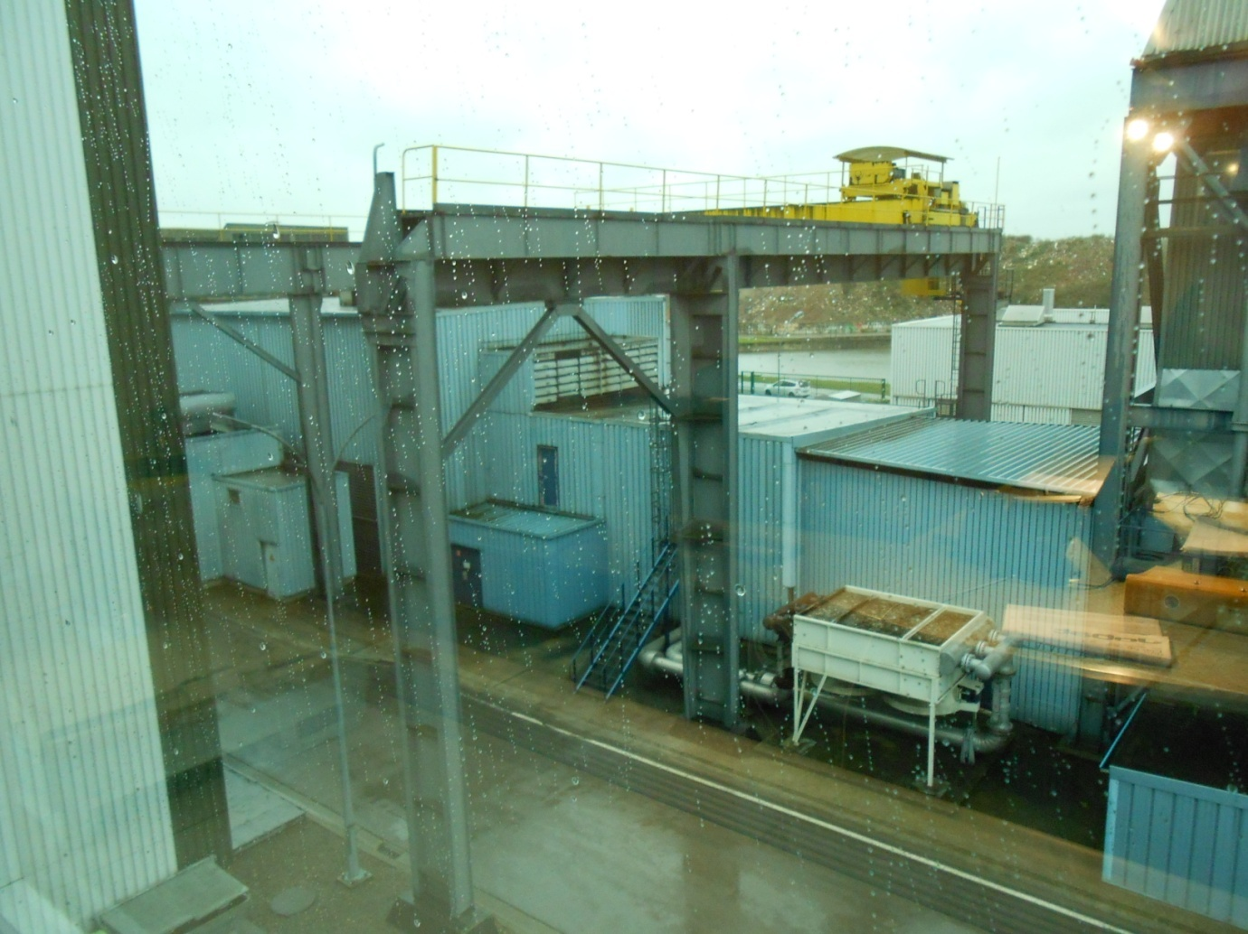

In service : 1976

Number of starts : +/- 3000

Total Running hours : 16690h

Last major overhaul : 2006

**Gasturbine W1101**

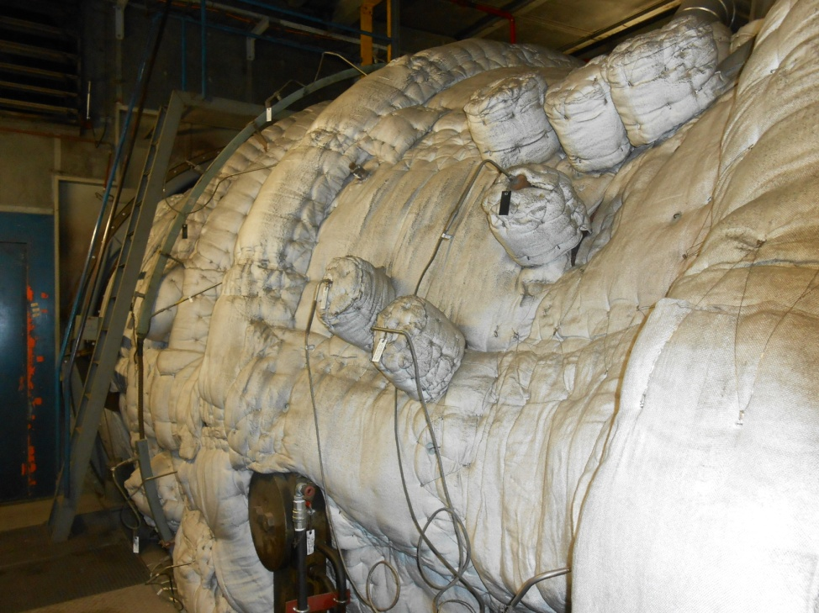

Specifications ECONOPAC W1101

|  |  |  |  |  |
| --- | --- | --- | --- | --- |
| ISO conditions | | | | |
|  | Natural gaz | | fuel | |
|  | Power (MW) | Heat rate(kcal/kWh) | Power (MW) | Heat rate(kcal/kWh) |
| Base load | 91,93 | 2804 | 90,14 | 2817 |
| Peak load | 99,28 | 2780 | 97,18 | 2795 |

Compressor : 20 rows

Power turbine : 4 rows

Combusters : 18

Speed 3000 rpm.

Startup time : 30 minutes (20 minutes quick start)

Natural gaz pressure : 17 bar.

Ref. :

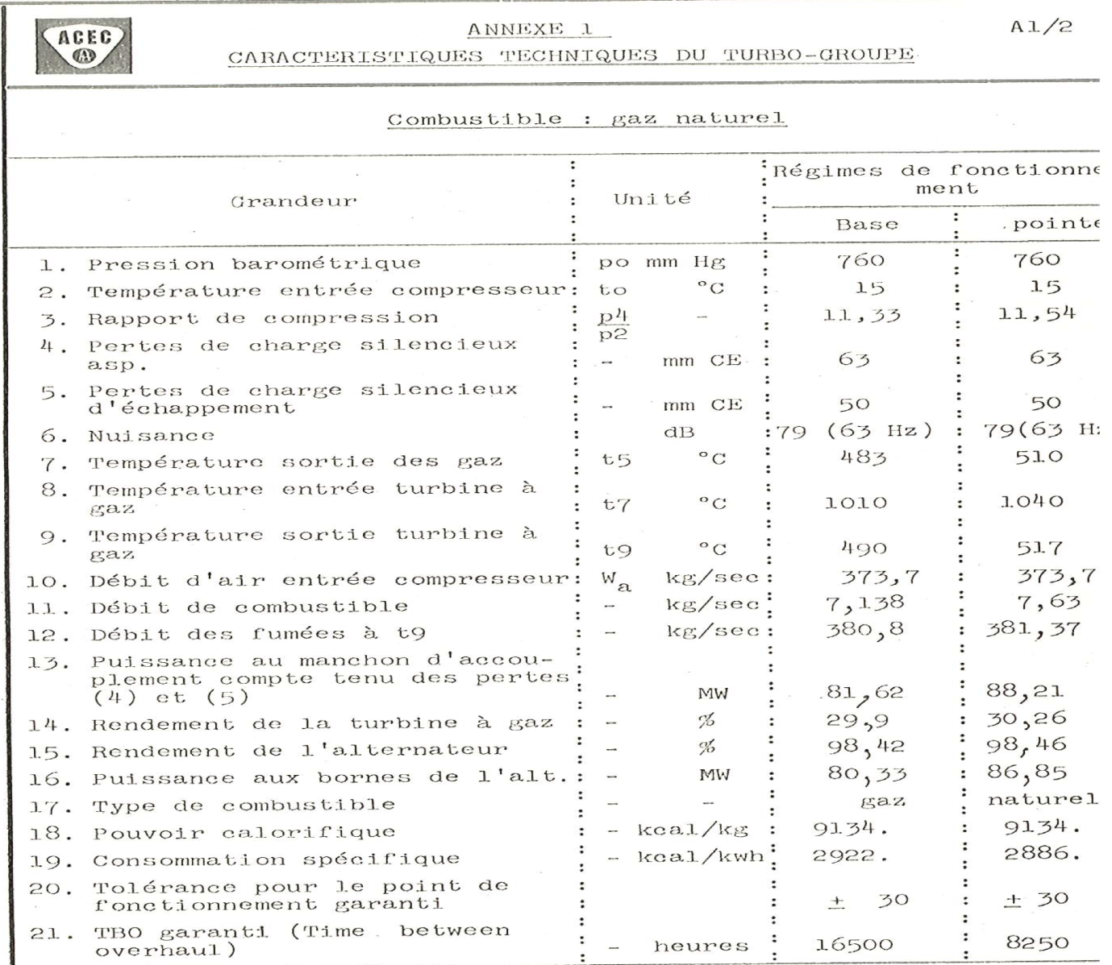

**Generator.**

ACEC/Westinghouse TAW1174

3000 rpm – 50 Hz

109 MVA

11 kV

Air cooled (+ heat exchanger air/water on top)

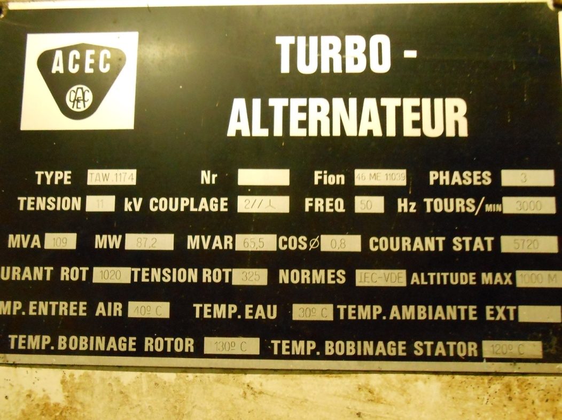

**Startup unit.**

Electrical motor : 2,65 MW, 6 kV

Oil clutch : 2700 HP

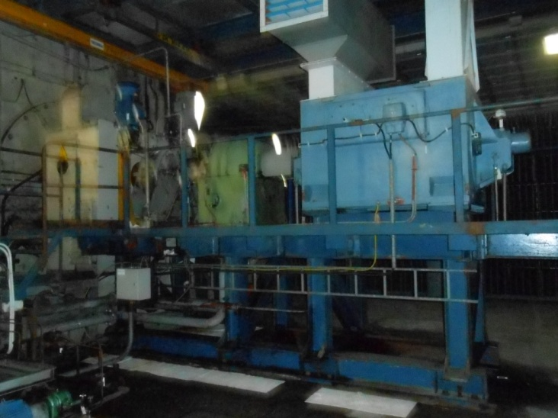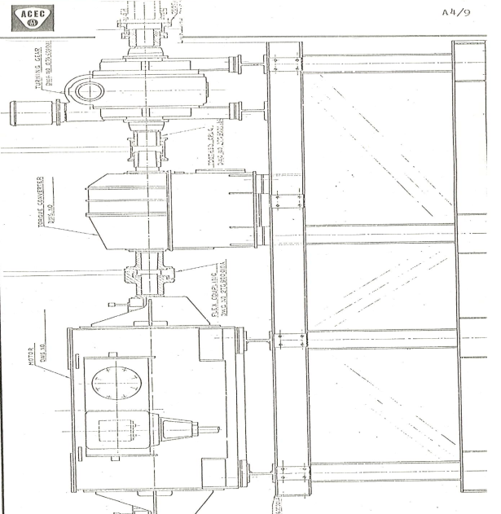

**Oil skid.**

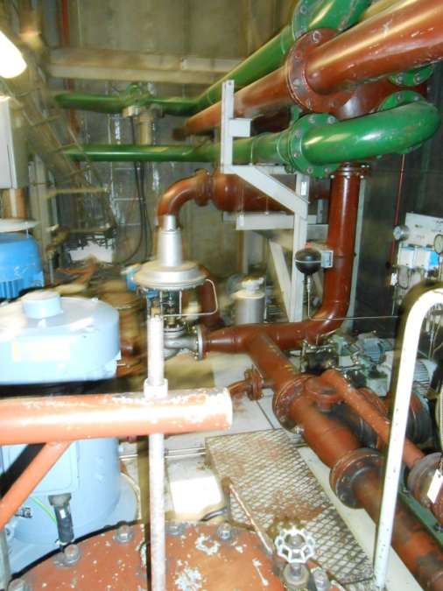

**Control system –DCS – MCC cabinets**

Cegelec: Cogito / Siemens. (installed 2007)

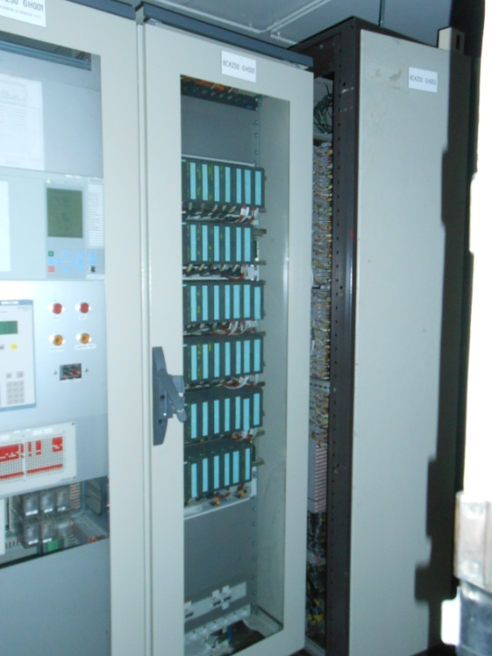 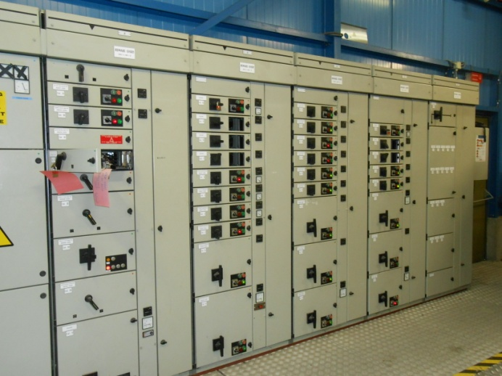

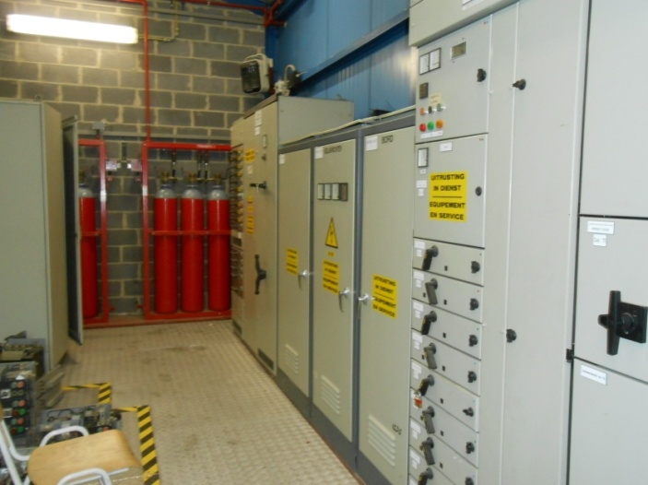

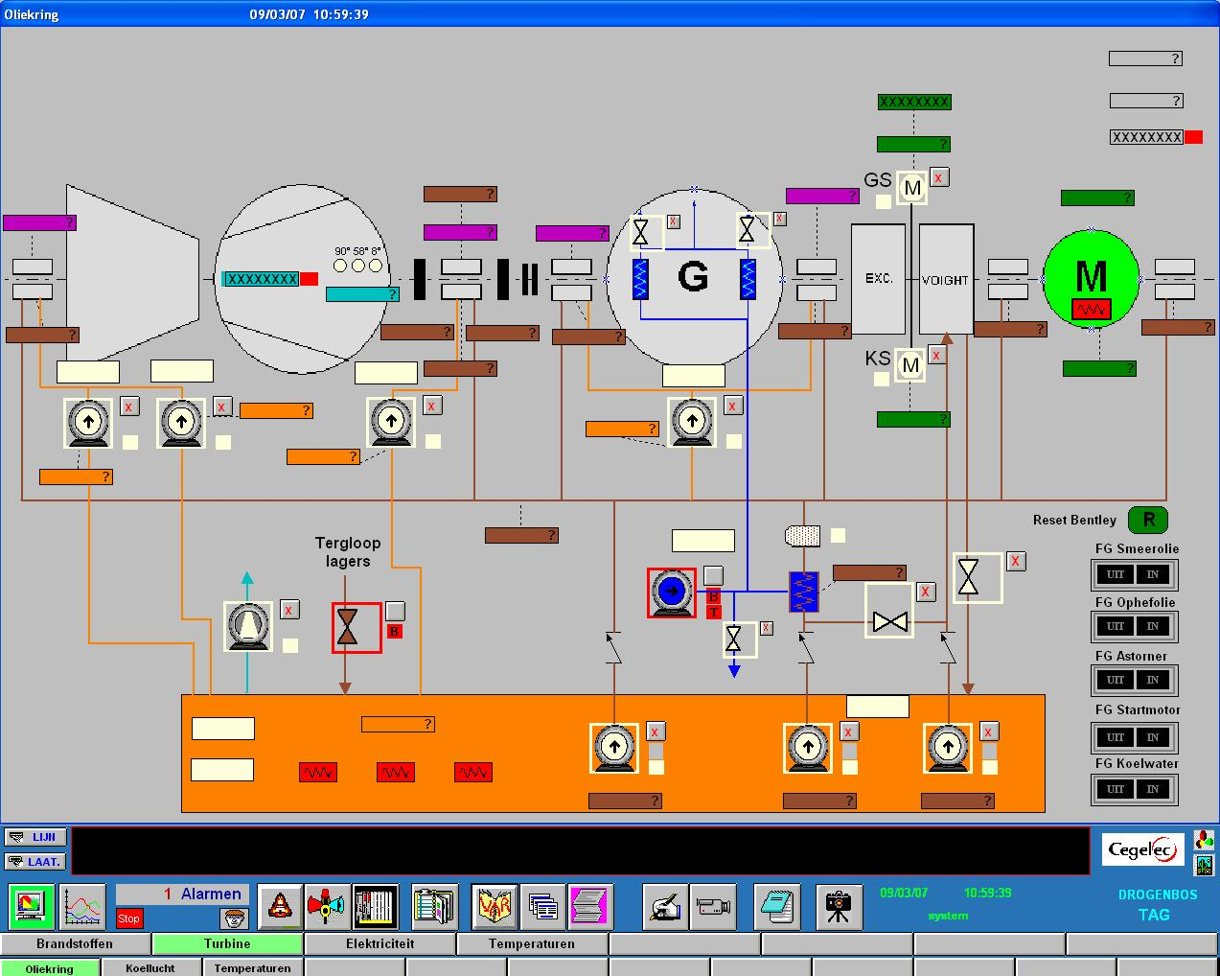

**Gaz reduction station.**

First stage reduction station.

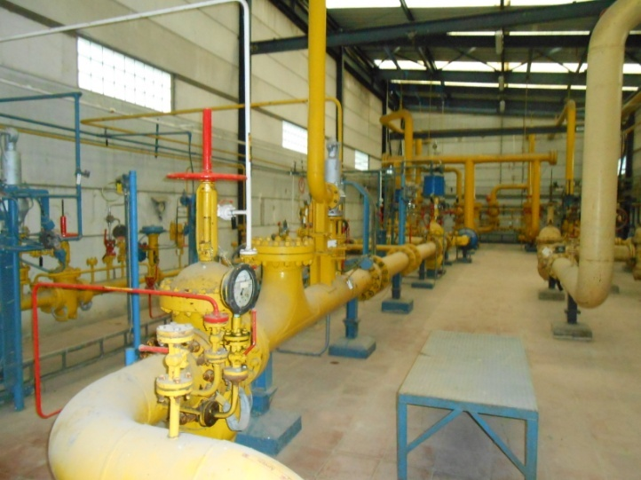

Second stage (17 bar)

